

|  |  |  |  |  |  |  |  |  |
| --- | --- | --- | --- | --- | --- | --- | --- | --- |
|  | | | | | | | | |
|  | | Assignment 1 Report | | | | |  | |
|  |  | | | | | | |  |
|  | | | |  |  | | | |
|  | | | | Bhosale Ratnesh Sambhajirao (19MF10010) |  | | | |
|  | | | | 08/03/2023—Dependable and Secure AI-ML—Prof. Ayantika Chatterjee. |  | | | |
|  | | |  | | |  | | |

|  |  |  |  |  |  |  |
| --- | --- | --- | --- | --- | --- | --- |
|  | | Assignment 1.1 | | |  | |
|  | |  |  |  |  | |
|  | Problem Statement:  * Use pretrained Resnet-50 to classify the image (use introduction notebook).   1) Take an image and find its class  2) Create an adversarial example for a targeted attack by adding random noise to the image  3) Feed it to the Resnet for prediction and find the predicted class of the image  (add the image and prediction for both before and after adding the noise in the image to your document) | | | | |  |
|  | Theory: ResNet is a type of convolutional neural network (CNN) first described in the 2015 paper "Deep Residual Learning for Image Recognition" by He Kaiming, Zhang Xiangyu, Ren Shaoqian, and Sun Jian. CNNs are frequently incorporated into computer vision applications.  ResNet-50 is a convolutional neural network with 50 layers (48 convolutional layers, one MaxPool layer, and one average pool layer). Residual neural networks are an artificial neural network (ANN) type that is formed by stacking residual blocks. ResNet-34, the original ResNet architecture, consisted of 34 weighted layers. Using the concept of shortcut connections, it provided a novel way to add more convolutional layers to a CNN without encountering the vanishing gradient problem. A shortcut connection "skips over" certain layers, thereby transforming a conventional network into a residual network.  The regular network was based on the VGG neural networks (VGG-16 and VGG-19), with each convolutional network containing a 33 filter. ResNet is less complex and contains fewer filters than VGGNet. A 34-layer ResNet can achieve 3.6 billion FLOPs, and a smaller 18-layer ResNet can achieve 1.8 billion FLOPs, which is significantly faster than a 19.6 billion FLOPs VGG-19 Network (read more in the ResNet paper, He et, al, 2015).  Architecture:  The architecture of ResNet-50 model. | Download Scientific Diagram  Fig. 1. Architecture of Resnet-50.  Loss function:   Results: Let's begin by classifying this image of a giant panda with the (pre-trained) ResNet50 model in PyTorch. The standard approach for image classification in PyTorch is to transform the image using the *torchvision.transforms* module (to approximately zero-mean, unit variance). Because we want to perturb the original (unnormalized) image space, we will take a slightly different approach and build the transformations at PyTorch layers so that we can feed the image directly. First, let's simply load the image and resize it to 224x224, which is the default input size for the majority of ImageNet images (and thus the pre-trained classifiers).    Fig. 2. Giant Panda Picture (taken as input to resnet-50)  Predictions now includes a 1000-dimensional vector that contains the class logits for the 1000 imagenet classes (i.e., if you wanted to convert this to a probability vector, you would apply the softmax operator to this vector). To find the class with the highest likelihood, we simply take the index of the maximum value in this vector and look up the corresponding label in a list of imagenet classes.Resnet 50 model identified the input image correctly as ‘*giant_panda*’. With the loss of 9.863505363464355.  Resnet 50 Model prediction: | | | | |  |
|  |  |

Fig. 3. Screenshot of Resnet 50 model prediction (Identified correctly.)

Creating Adversarial Attack:

We follow each step with a projection back onto the ℓ∞ ball (done by simply clipping the values that exceed ϵ magnitude to ±ϵ ), this is actually a procedure known as projected gradient descent (PGD).

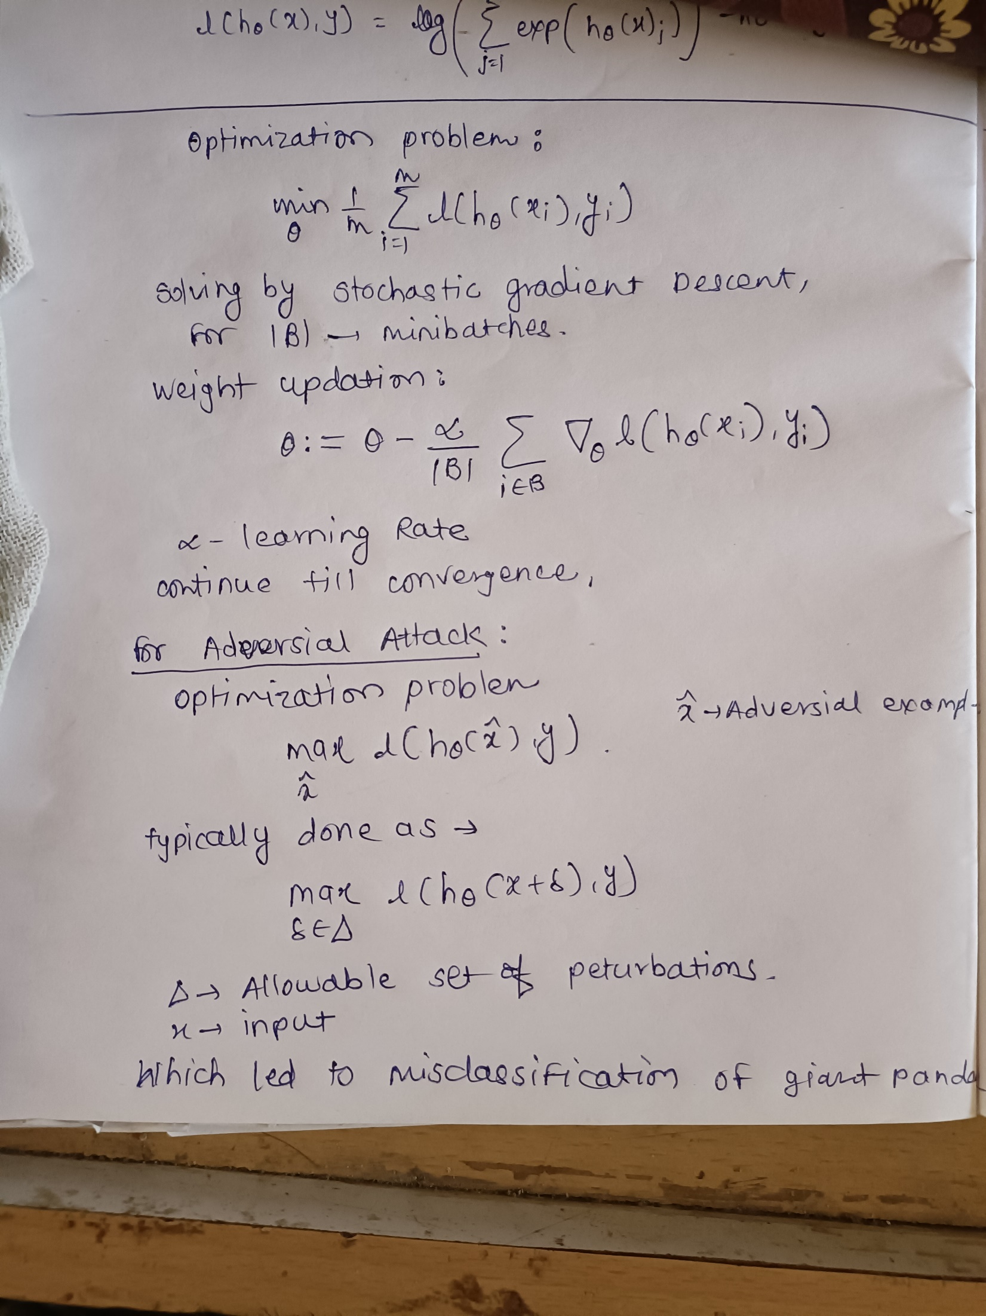

After Attack:

After adversial attack, there is no significant change in image, but model’s prediction is changed to “*airliner*” from “*giant_panda*”.

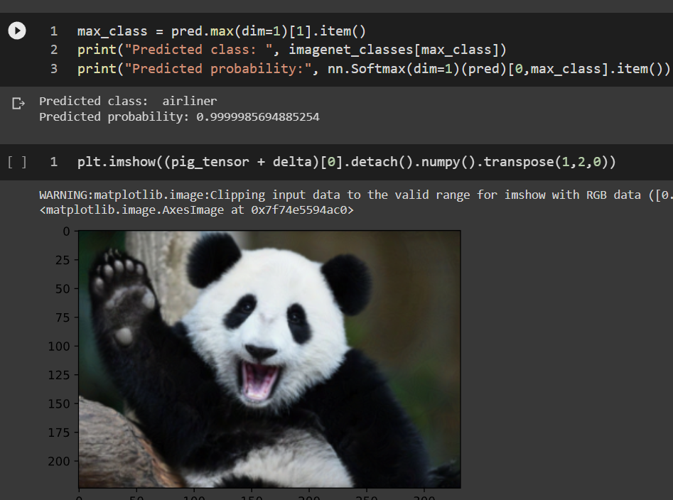

Fig. 4. Screenshot of Resnet 50 model prediction after attack (Identified **Incorrectly**.)

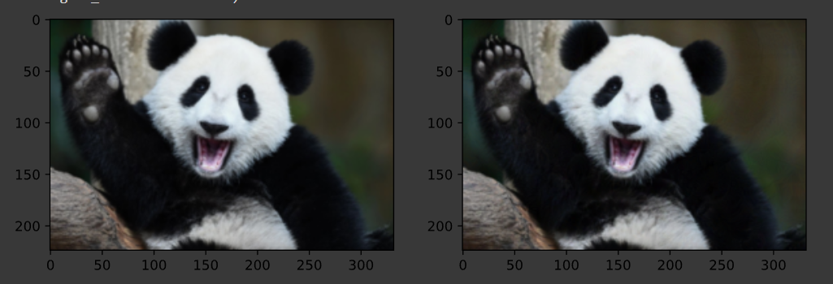

Fig. 5. (a) Image predicted as “giant_panda” by resnet50 model. (before attack) (b) Image predicted as “airliner” by resnet50 model. (after attack)

|  |  |  |  |  |  |  |
| --- | --- | --- | --- | --- | --- | --- |
|  | | Assignment 1.2 | | |  | |
|  | |  |  |  |  | |
|  | Problem Statement:  * Constructing adversarial examples using:   1) Fast Gradient Sign Method (FGSM) by varying epsilon between [0.1, 0.001] (randomly take five values)  2) Projected gradient descent (PGD)  3) PGD with infinity norm  4) PGD infinity norm with a targeted attack  5) PGD l2 norm by varying epsilon, alpha between [0.1, 0.001]  (Take five values at random and do this for each method). Create a table with epsilon, alpha, and iterations as columns and optimization methods as rows.  Compare the misclassification rate relative to all methods. Add screenshots of all outputs in the document. | | | | |  |
|  | Theory:     Fig. 6. The architecture of neural network model. | | | | |  |

These loss surfaces result in two major obstacles. First, in the high dimensional setting that we will typically consider with deep networks, there is a high probability that at almost any point in input space there will be a very steep direction along the loss surface, i.e., a direction that causes the loss to either increase or decrease significantly. This is the mathematical equivalent of what we observed in the introductory chapter: that moving a small distance in input space (i.e., having a small perturbation) results in a significant increase in loss.

The second difficulty is that, unlike the linear case, the inner maximization problem over our perturbation is difficult to solve (or easily upper bound, as we did in the multiclass linear case). This is because, as shown in the preceding diagram, the cost surface for neural networks (considered here over the input space, not the parameter space) is not convex and is particularly susceptible to local optima. Even in the simple example presented previously, there are local optimal solutions when attempting to maximize or minimize the function, and the initial gradient at any given point may or may not point in the direction of the actual maxima. This second point may be less of a concern if our objective is to simply construct an adversarial example against a standard deep network (after all, as the first point illustrated, there are multiple directions of high cost increase, and simply following the gradient typically results in an adversarial example, even if it is not the optimal adversarial example. However, when we later consider training robust networks, this will be a major issue, as Danskin's theorem will no longer hold, and we will be unable to solve the true robust optimization problem.

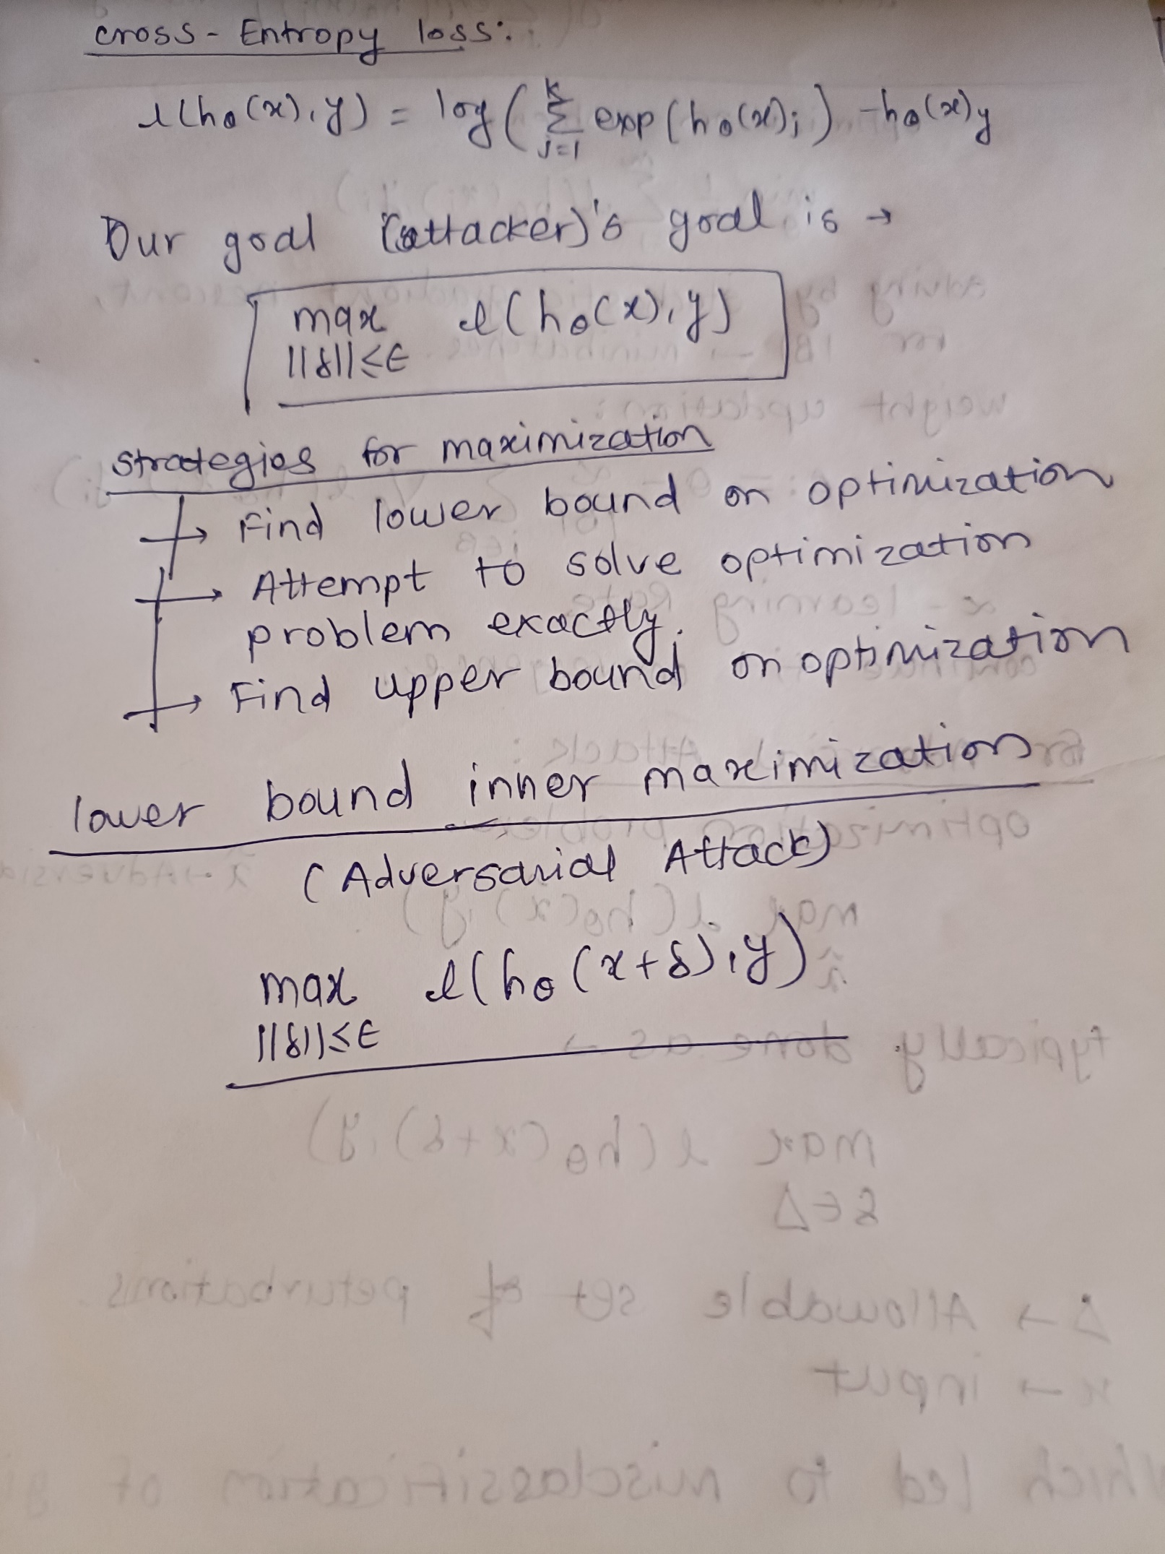

Dataset used for attacks: MNIST.

Original Prediction: (test accuracy = 94.44%)

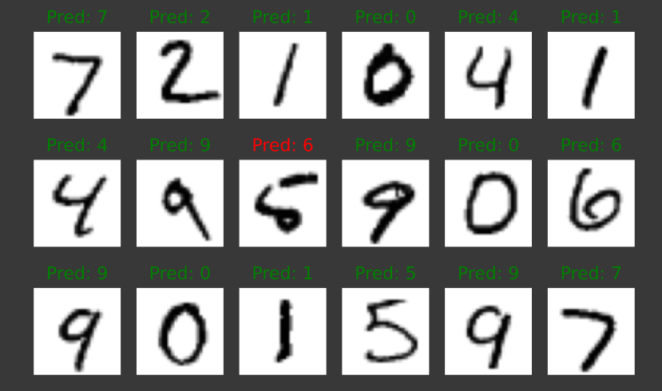

**1.2.1 The Fast Gradient Sign Method (FGSM)**

Mathematics behind FGSM is:

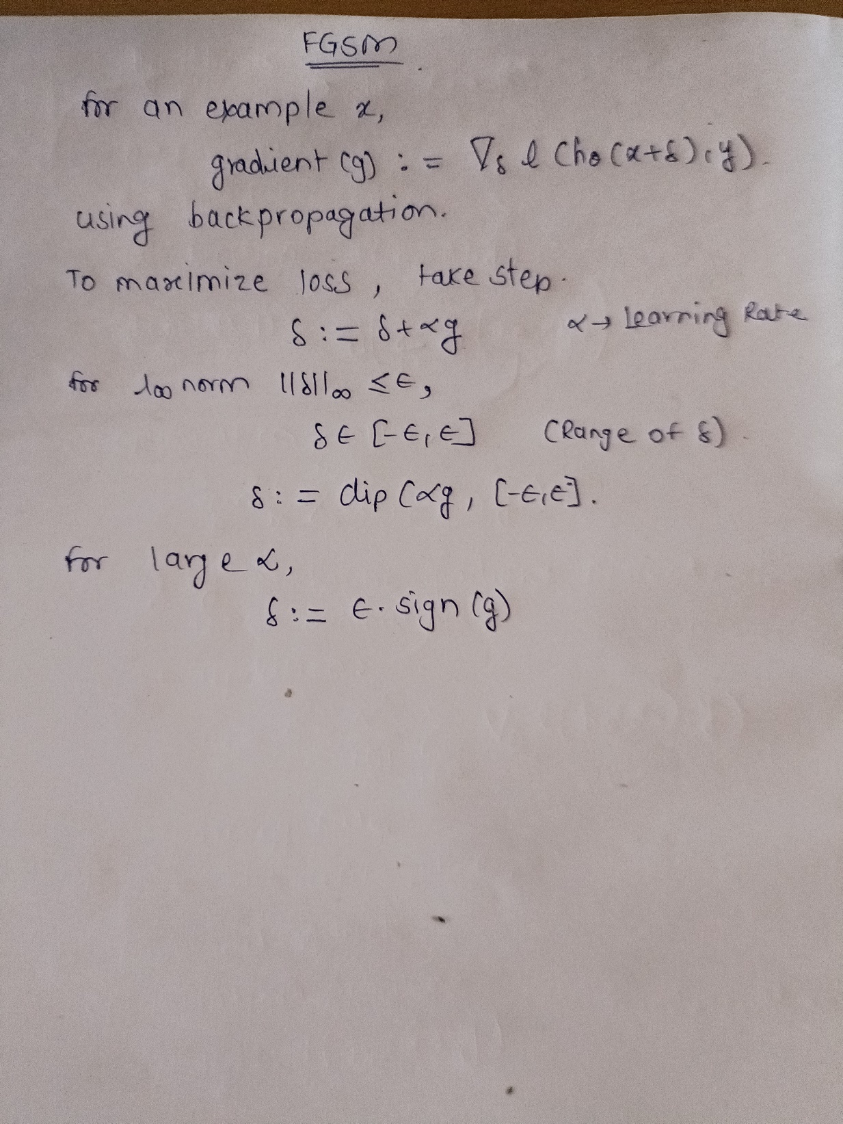

FGSM using PyTorch is:

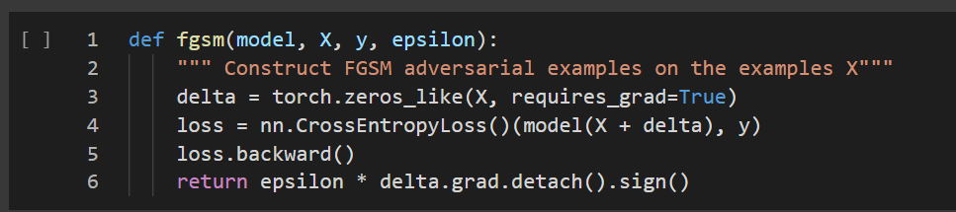

Evaluate the effectiveness of the attack methods:

Table 1. Variation in epsilon.

|  |  |  |
| --- | --- | --- |
| **Epsilon** | **Test Accuracy (DNN)** | **Test Accuracy (CNN)** |
| 0.1 | 5.56% | 44.44% |
| 0.07 | 16.67% | 66.67% |
| 0.04 | 77.78% | 100.00% |
| 0.005 | 94.44% | 100.00% |
| 0.001 | 94.44% | 100.00% |

Chart 1. Epsilon vs Accuracy (FGSM)

A few important points about FGSM must be made. First, it is essential to emphasize that FGSM is specifically an attack under a l∞ norm bound: FGSM consists of a single step of projected gradient descent under the l∞ constraint. Consequently, we must evaluate FGSM in the context of other l∞ attacks. As epsilon increases, accuracy of prediction increases.

Screenshots after FGSM Attack:

1. DNN (2 layers):

Epsilon = 0.1 Epsilon = 0.07 Epsilon = 0.04

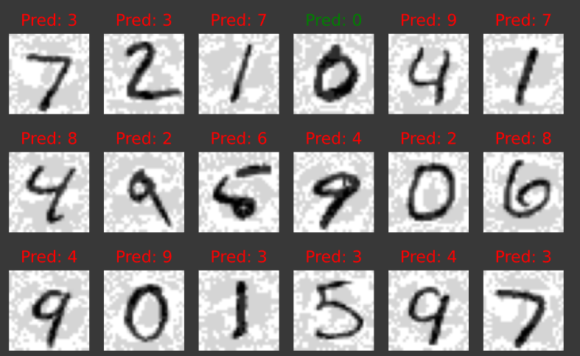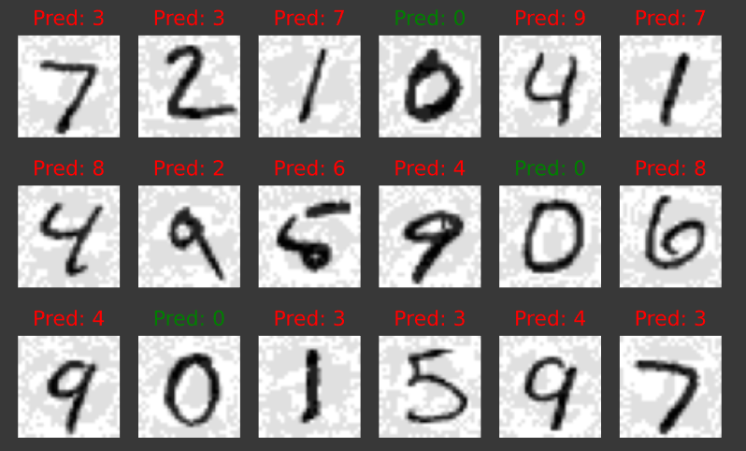 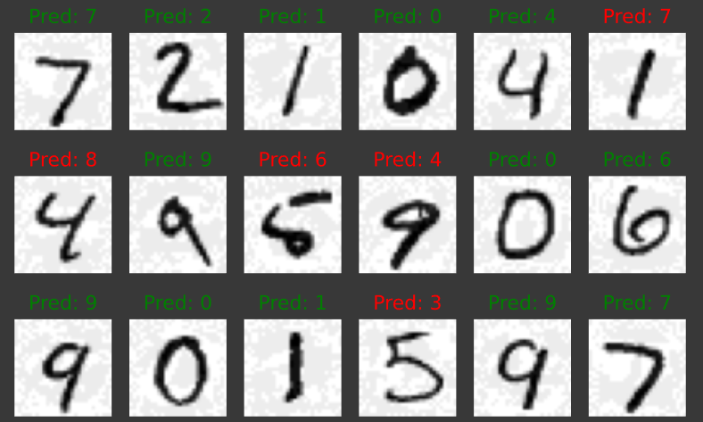

Epsilon = 0.005 Epsilon = 0.001

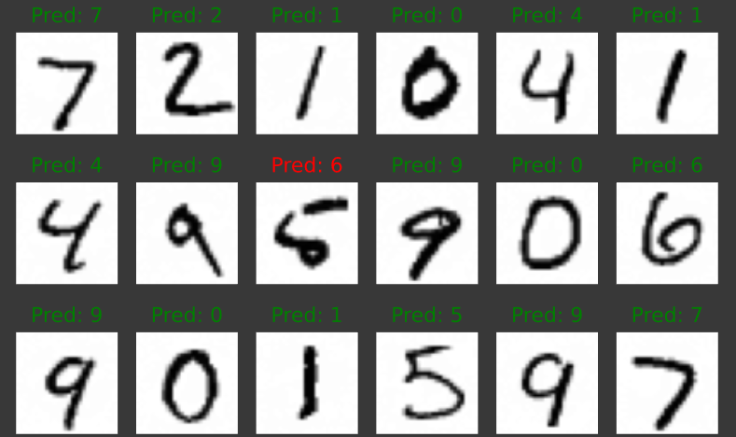 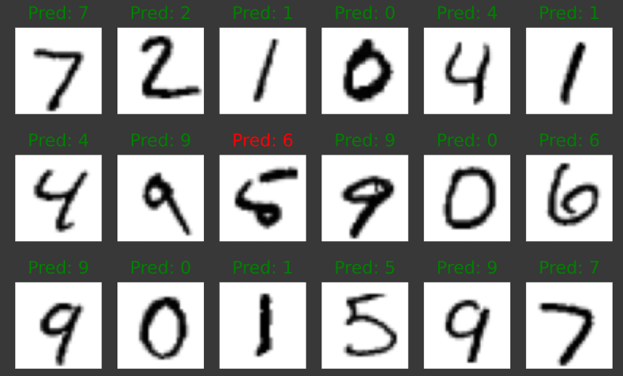

1. CNN

Epsilon = 0.1 Epsilon = 0.07 Epsilon = 0.04

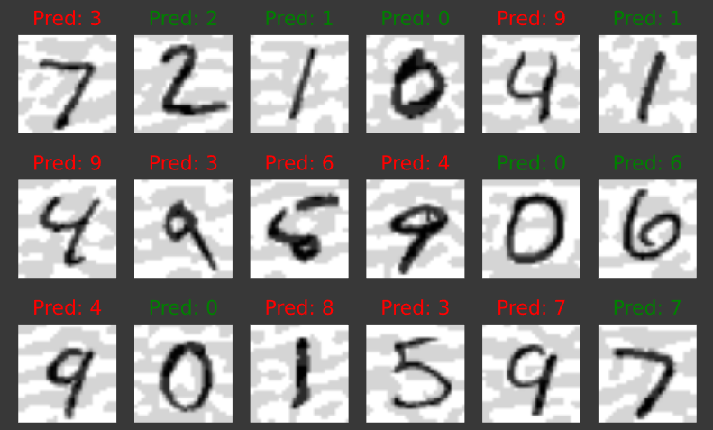 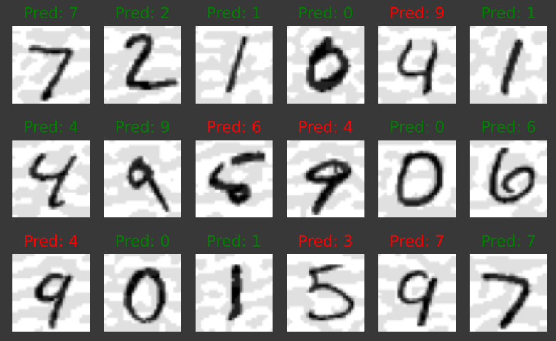 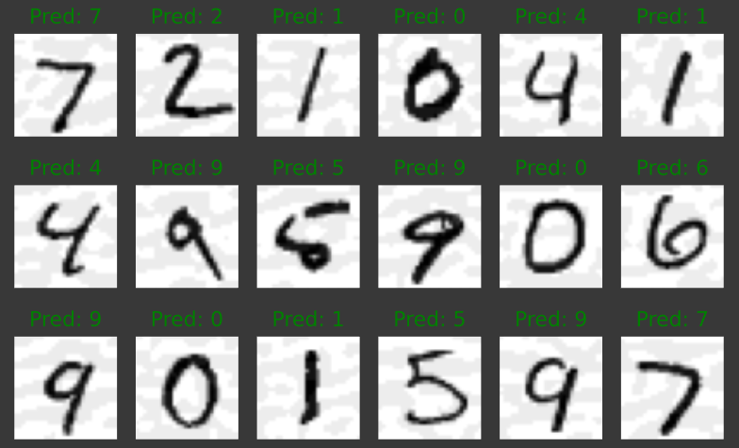

Epsilon = 0.005 Epsilon = 0.001

 

**1.2.2 Projected Gradient Descent.**

Mathematics behind PGD is:

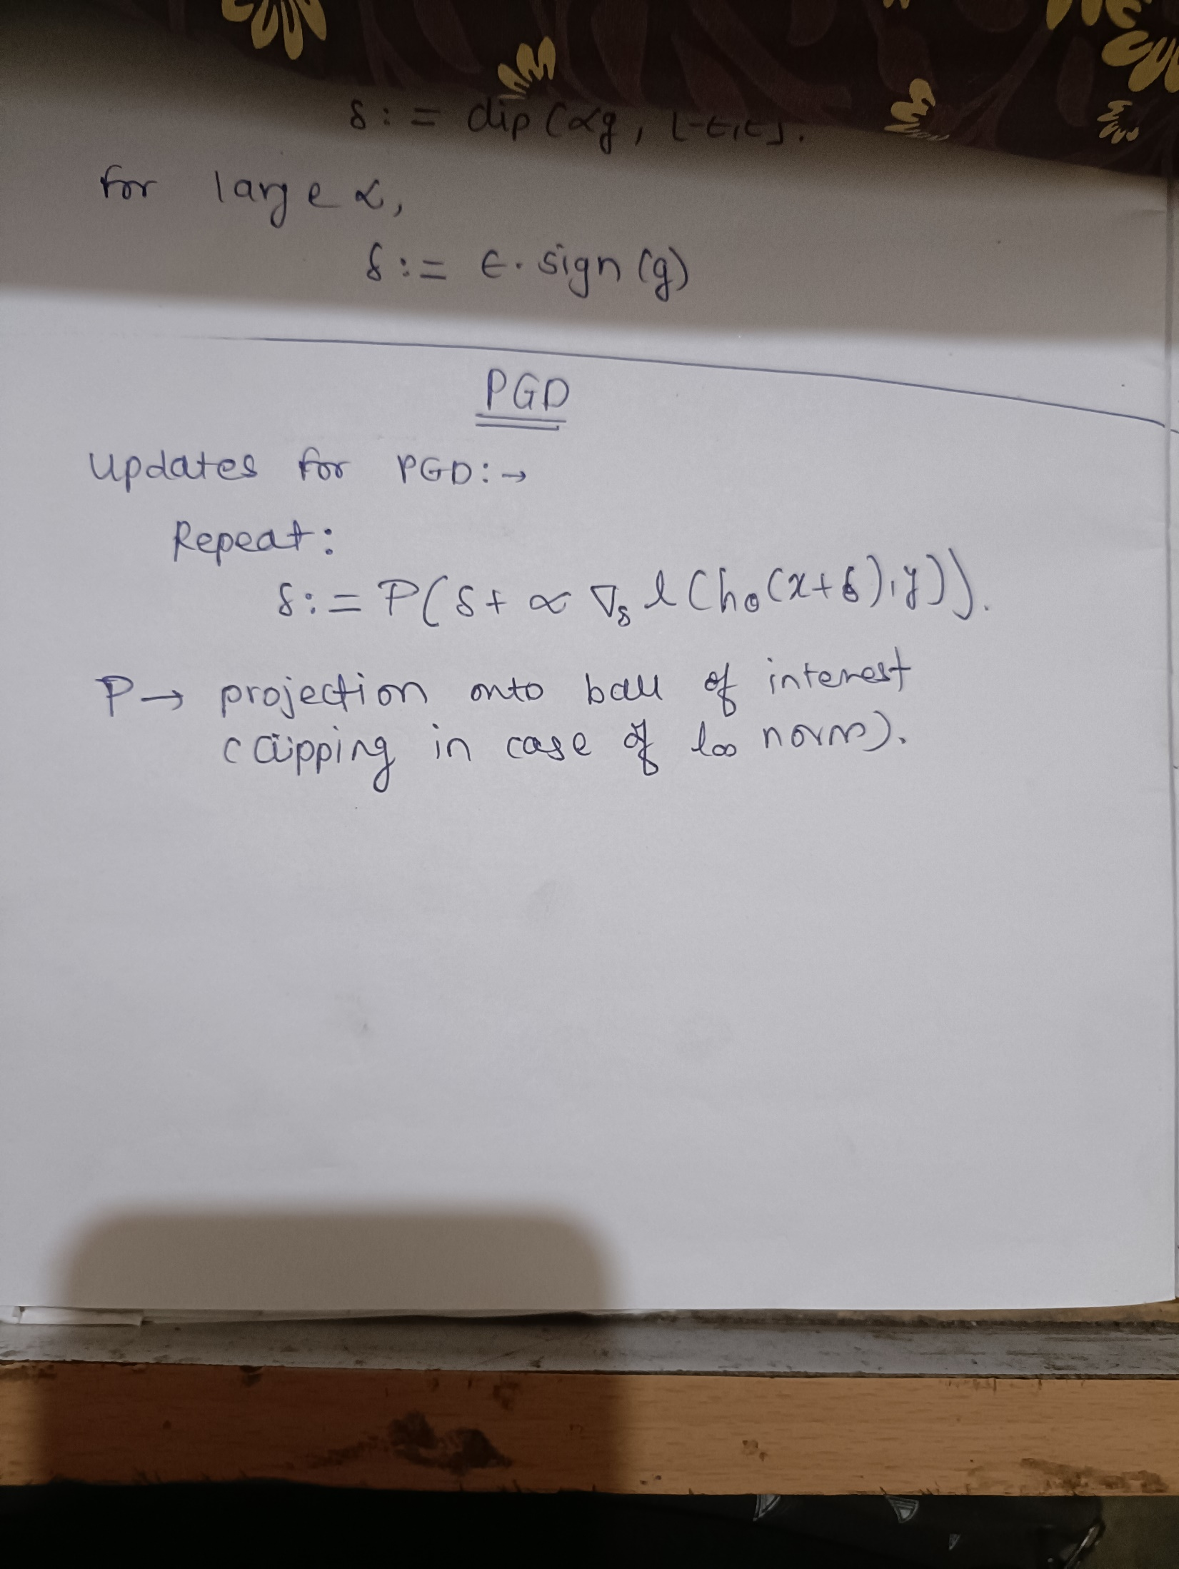

PGD using PyTorch is:

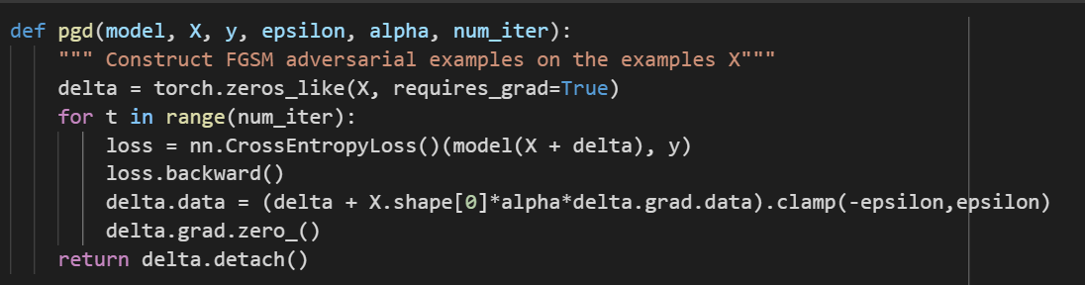

Evaluate the effectiveness of the attack methods:

Table 2. Variation in epsilon and alpha (PGD).

|  |  |  |  |
| --- | --- | --- | --- |
| **Epsilon** | **Alpha** | **Iterations** | **Test Accuracy (CNN)** |
| 0.1 | 0.001 | 1000 | 100.00% |
| 0.07 | 0.02 | 1000 | 94.44% |
| 0.04 | 0.008 | 1000 | 94.44% |
| 0.005 | 0.01 | 1000 | 100.00% |
| 0.001 | 0.06 | 1000 | 100.00% |

Chart 2. Epsilon, alpha and Accuracy (PGD)

Screenshots after PGD Attack:

Epsilon = 0.1 & alpha = 0.001 Epsilon = 0.07 & alpha = 0.02 Epsilon = 0.04 & alpha = 0.008

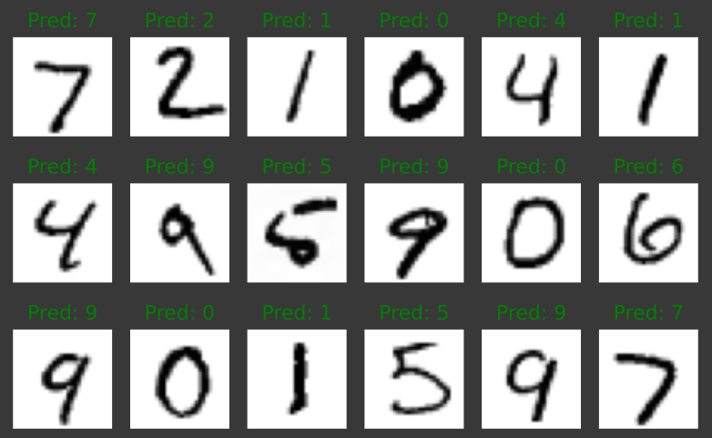 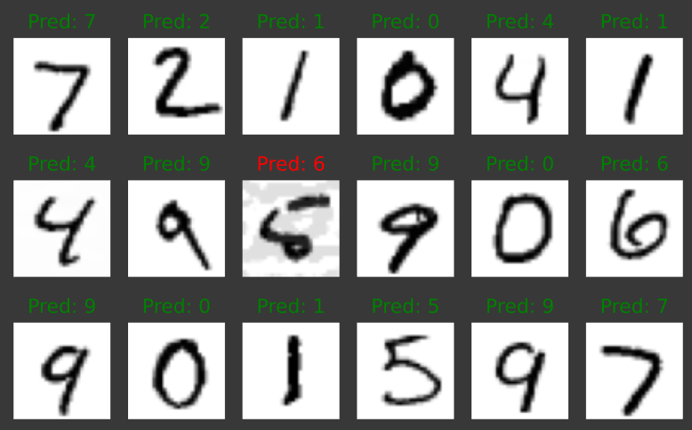 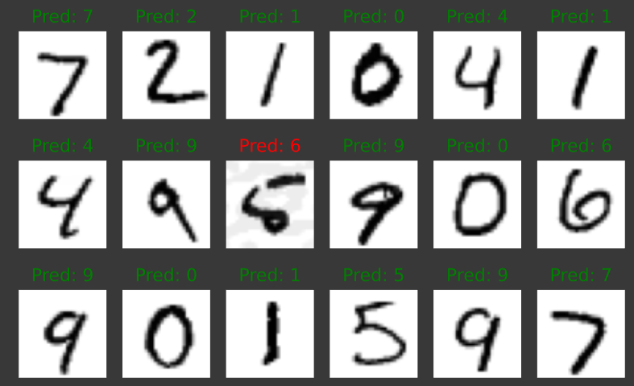

Epsilon = 0.005 & alpha = 0.01 Epsilon = 0.001 & alpha = 0.06

 

Cross-Entropy Loss – 3.14 x 10-6

**1.2.3 Projected Gradient Descent with infinity norm.**

Mathematics behind PGD (infinity norm) is:

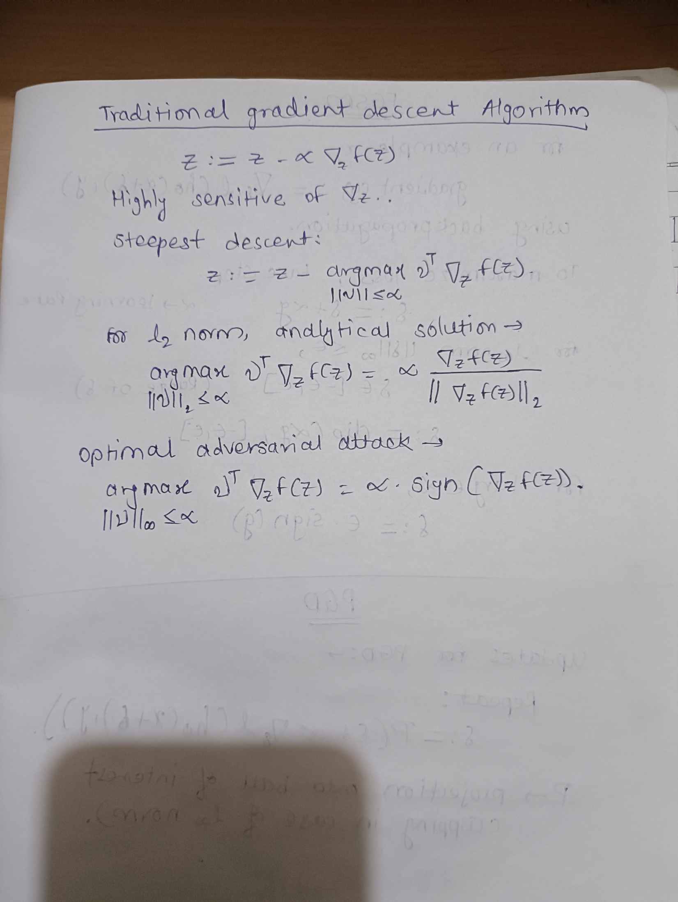

PGD (inf norm) using PyTorch is:

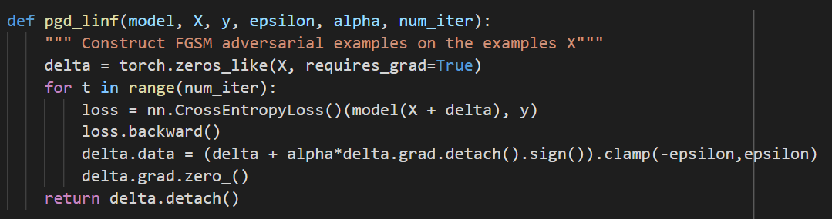

Evaluate the effectiveness of the attack methods:

Table 3. Variation in epsilon and alpha (PGD inf norm).

|  |  |  |  |
| --- | --- | --- | --- |
| **Epsilon** | **Alpha** | **Iterations** | **Test Accuracy (CNN)** |
| 0.1 | 0.02 | 40 | 16.66% |
| 0.07 | 0.001 | 40 | 94.44% |
| 0.04 | 0.05 | 40 | 94.44% |
| 0.005 | 0.01 | 40 | 100.00% |
| 0.001 | 0.06 | 40 | 100.00% |

Chart 3. Epsilon, alpha and Accuracy (PGD – infinity norm)

Epsilon = 0.1 & alpha = 0.02 Epsilon = 0.07 & alpha = 0.001 Epsilon = 0.04 & alpha = 0.05

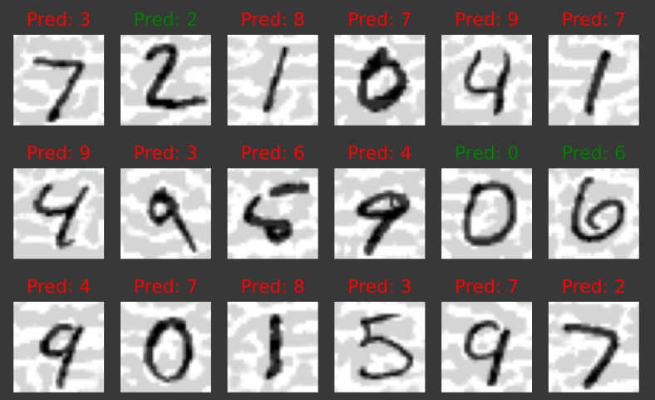 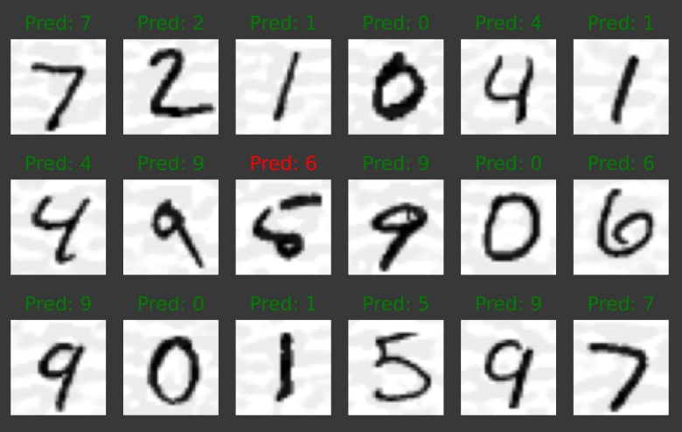 

Epsilon = 0.005 & alpha = 0.01 Epsilon = 0.001 & alpha = 0.06

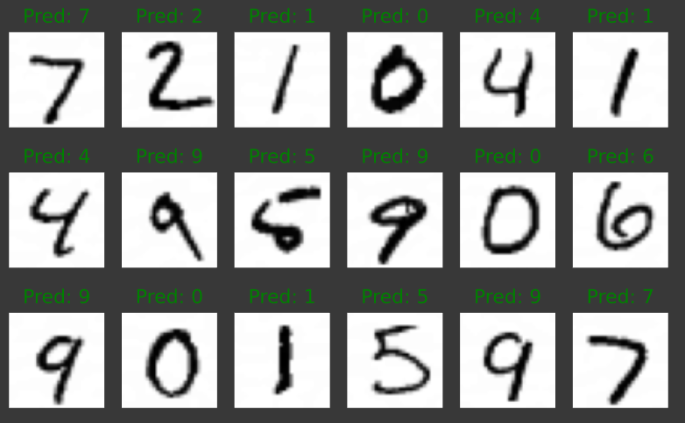 

Cross-Entropy Loss – 3.14 x 10-6

**1.2.4 Projected Gradient Descent with infinity norm with targeted attack.**

Mathematics behind PGD (infinity norm) with targeted attack is:



PGD (inf norm) with targeted attack using PyTorch is:

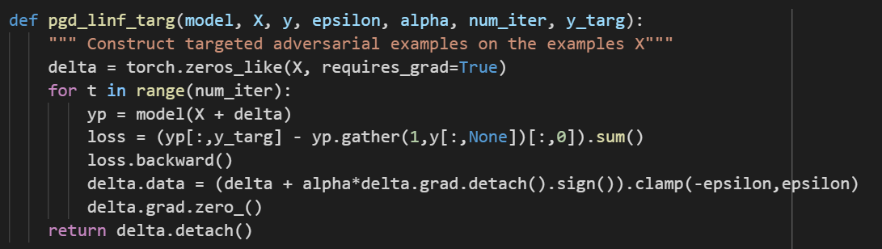

Evaluate the effectiveness of the attack methods:

Y(targeted) is set to 2.

Table 4. Variation in epsilon and alpha (PGD inf norm with targeted attack at y=2).

|  |  |  |  |
| --- | --- | --- | --- |
| **Epsilon** | **Alpha** | **Iterations** | **Test Accuracy (CNN)** |
| 0.1 | 0.01 | 40 | 50.00% |
| 0.07 | 0.08 | 40 | 77.77% |
| 0.04 | 0.004 | 40 | 100.00% |
| 0.005 | 0.1 | 40 | 100.00% |
| 0.001 | 0.002 | 40 | 100.00% |

Chart 4. Epsilon, alpha and Accuracy (PGD – infinity norm) with target is y=2

Y(targeted) is set to 2.

Table 5. Variation in epsilon and alpha (PGD inf norm with targeted attack at y=0).

|  |  |  |  |
| --- | --- | --- | --- |
| **Epsilon** | **Alpha** | **Iterations** | **Test Accuracy (CNN)** |
| 0.1 | 0.01 | 40 | 94.44% |
| 0.07 | 0.08 | 40 | 100.00% |
| 0.04 | 0.004 | 40 | 100.00% |
| 0.005 | 0.1 | 40 | 100.00% |
| 0.001 | 0.002 | 40 | 100.00% |

Chart 5. Epsilon, alpha and Accuracy (PGD – infinity norm) with target is y=2

Y(targeted) is set to 0.

1. *y_target = 2*

Epsilon = 0.1 & alpha = 0.01 Epsilon = 0.07 & alpha = 0.08 Epsilon = 0.04 & alpha = 0.004

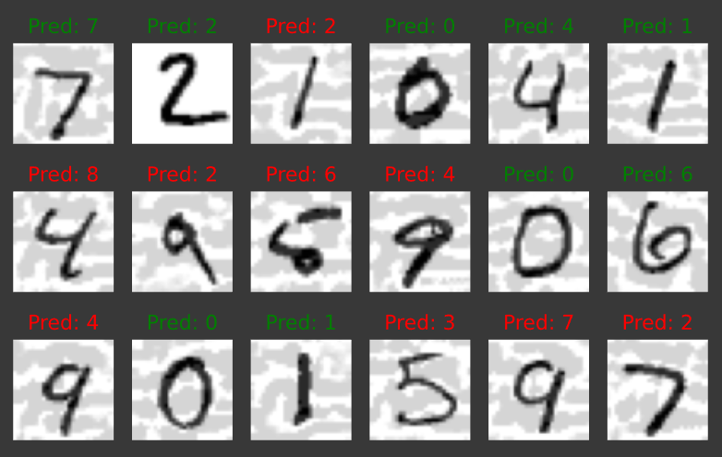 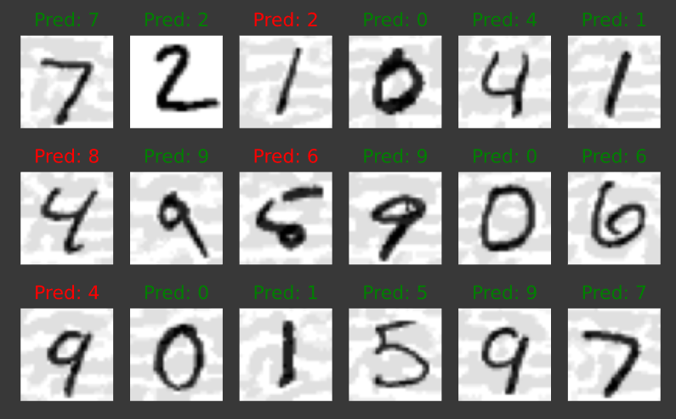 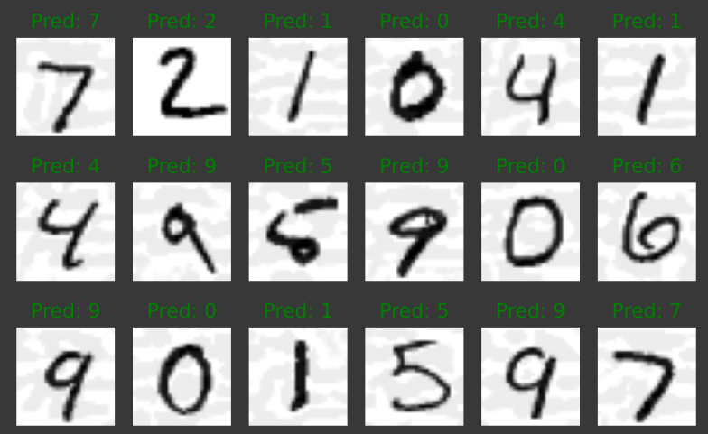

Epsilon = 0.005 & alpha = 0.1 Epsilon = 0.001 & alpha = 0.002

 

1. *y_target = 0*

Epsilon = 0.1 & alpha = 0.01 Epsilon = 0.07 & alpha = 0.08 Epsilon = 0.04 & alpha = 0.004

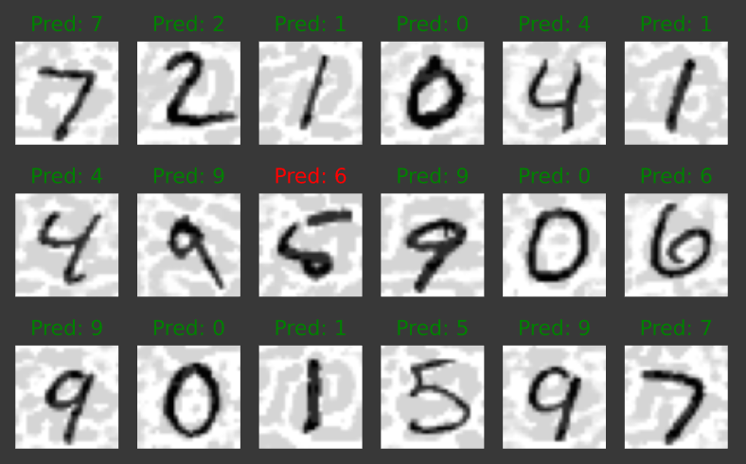 

Epsilon = 0.005 & alpha = 0.1 Epsilon = 0.001 & alpha = 0.002

 

**1.2.5 Projected Gradient Descent with l2 norm**

Mathematics behind PGD (l2 norm) is:

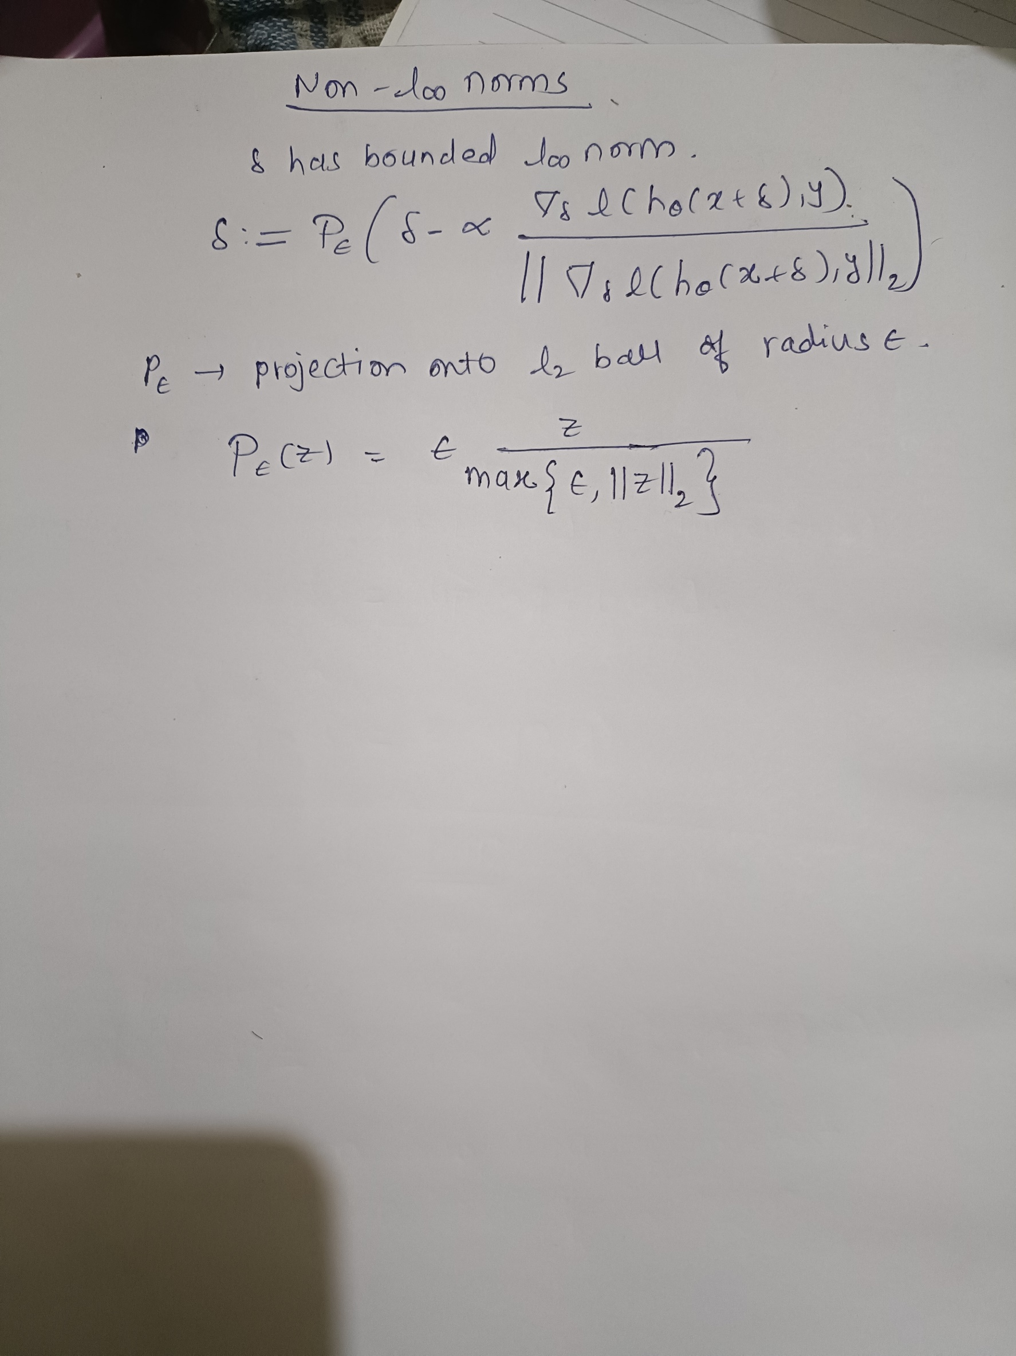

PGD (l2 norm) with targeted attack using PyTorch is:

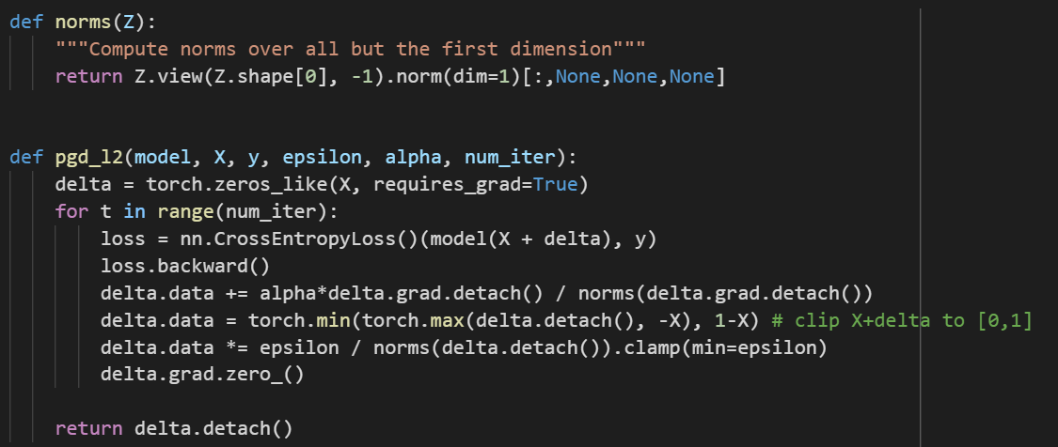

Table 6. Variation in epsilon and alpha (PGD l2 norm).

|  |  |  |  |
| --- | --- | --- | --- |
| **Epsilon** | **Alpha** | **Iterations** | **Test Accuracy (CNN)** |
| 0.1 | 0.1 | 40 | 100.00% |
| 0.07 | 0.001 | 40 | 100.00% |
| 0.04 | 0.05 | 40 | 100.00% |
| 0.005 | 0.09 | 40 | 100.00% |
| 0.001 | 0.001 | 40 | 100.00% |

Chart 6. Epsilon, alpha and Accuracy (PGD – l2 norm)

Epsilon = 0.1 & alpha = 0.1 Epsilon = 0.07 & alpha = 0.001 Epsilon = 0.04 & alpha = 0.05

  

Epsilon = 0.005 & alpha = 0.09 Epsilon = 0.001 & alpha = 0.001

 

**1.2.6 Conclusion**

Table 7. Accuracy comparison of all optimizers).

|  |  |  |  |  |  |  |
| --- | --- | --- | --- | --- | --- | --- |
| Optimizer | Epsilon | | | | | Alpha |
| 0.1 | 0.07 | 0.04 | 0.005 | 0.001 |
| FGSM | 44.44% | 66.67% | 100.00% | 100.00% | 100.00% | NA |
| PGD  (no of iterations = 1000) | 100.00% |  |  |  |  | 0.001 |
|  | 94.44% |  |  |  | 0.02 |
|  |  | 94.44% |  |  | 0.008 |
|  |  |  | 100.00% |  | 0.01 |
|  |  |  |  | 100.00% | 0.06 |
| PGD (inf norm)  (no of iterations = 40) | 16.66% |  |  |  |  | 0.02 |
|  | 94.44% |  |  |  | 0.001 |
|  |  | 94.44% |  |  | 0.05 |
|  |  |  | 100.00% |  | 0.01 |
|  |  |  |  | 100.00% | 0.06 |
| PGD (inf norm) (no of iterations = 40 and y_target =2) | 50.00% |  |  |  |  | 0.01 |
|  | 77.77% |  |  |  | 0.08 |
|  |  | 100.00% |  |  | 0.004 |
|  |  |  | 100.00% |  | 0.1 |
|  |  |  |  | 100.00% | 0.002 |
| PGD (l2 norm) | 100.00% |  |  |  |  | 0.1 |
|  | 100.00% |  |  |  | 0.001 |
|  |  | 100.00% |  |  | 0.05 |
|  |  |  | 100.00% |  | 0.09 |
|  |  |  |  | 100.00% | 0.001 |

From the above chart we can conclude the misclassification rate decreases as we decrease epsilon. There is no direct trend between alpha and epsilon is seen. These modifications do not appear to have a significant impact on the adversarial trainability of deep models on large epsilons. The training loss does not decrease when we attempt to apply adversarial training to large epsilons. In addition, we attempt to train the models adversarial by adopting various architectures, optimizers, learning rates, weight initializations, and PGD settings. Initializations based on standard trained models are also observed to be ineffective in this context, indicating that adversarially trained model weights are inherently distinct from standard trained model weights. Observations indicate that the adversarial accuracy under attacks with bounded '2 norm improves in models trained using the proposed method.